# Dominik Ciesiołkiewicz 44289 – Sprawozdanie Lab 8 Kodowanie kanałowe – TD

*\*Dla przejrzystości na końcu kodu umieściłem zrzuty z konsoli ze zwykłego kodowania jak i SECDEC*

**Kod:**

#include <iostream>

#include <fstream>

#include <complex>

using namespace std;

int lengthOfString(string str)

{

return str.length();

}

string S2BS(string in, bool choice) //String To Binary Stream

{

string out = "";

int n = in.length();

string bity = "";

if (choice == 1)//LittleEndian

{

for (int i = 0; i < n; i++)

{

int wartosc = int(in[i]);

bity = "";

while (wartosc > 0)

{

if (wartosc % 2)

{

bity += '1';

}

else

{

bity += '0';

}

wartosc = wartosc / 2;

}

out += bity;

}

reverse(out.begin(), out.end());

//cout << out << endl;

return out;

}

else {//BigEndian

for (int i = 0; i < n; i++)

{

int wartosc = int(in[i]);

bity = "";

while (wartosc > 0)

{

if (wartosc % 2)

{

bity += '1';

}

else

{

bity += '0';

}

wartosc = wartosc / 2;

}

reverse(bity.begin(), bity.end());

out += bity;

}

//cout << out << endl;

return out;

}

}

int* Hamming(string d)

{

int G[7][4] = { {1,1,0,1},{1,0,1,1},{1,0,0,0},{0,1,1,1},{0,1,0,0},{0,0,1,0},{0,0,0,1} };

int* K = new int[7];

for (int i = 0; i < 7; i++)

{

K[i] = 0;

for (int j = 0; j < 4; j++)

{

//cout << G[i][j];

//cout<<d[j]<<endl;

K[i] += G[i][j] * (d[j] - '0');

}

//cout << endl;

}

cout << "K:" << endl;

for (int i = 0; i < 7; i++)

{

cout << K[i] << endl;

}

cout << endl;

cout << "K modulo 2:" << endl;

for (int i = 0; i < 7; i++)

{

K[i] = K[i]%2;

cout << K[i] << endl;

}

cout << endl;

return K;

}

int* HammingSECDEC(string d)

{

int G[7][4] = { {1,1,0,1},{1,0,1,1},{1,0,0,0},{0,1,1,1},{0,1,0,0},{0,0,1,0},{0,0,0,1} };

int* K = new int[8];

for (int i = 0; i < 7; i++)

{

K[i] = 0;

for (int j = 0; j < 4; j++)

{

K[i] += G[i][j] * (d[j] - '0');

}

}

cout << "K:" << endl;

for (int i = 0; i < 7; i++)

{

cout << K[i] << endl;

}

cout << endl;

cout << "K modulo 2:" << endl;

for (int i = 0; i < 7; i++)

{

K[i] = K[i] % 2;

cout << K[i] << endl;

}

cout << endl;

//Dla SECDEC:

cout << "Ze sprawdzajacym bitem: " << endl;

int err = 0;

for (int i = 0; i < 7; i++)

{

err += K[i];

}

err = err % 2;

K[7] = err;

for (int i = 0; i < 8; i++)

{

cout << K[i] << endl;

}

cout << endl;

return K;

}

int* DecHamming(int * K)

{

{

int H[3][7] = { {1,0,1,0,1,0,1},{0,1,1,0,0,1,1},{0,0,0,1,1,1,1} };

int* KD = new int[7];

for (int i = 0; i < 3; i++)

{

KD[i] = 0;

for (int j = 0; j < 7; j++)

{

//cout << K[j];

KD[i] += H[i][j] * K[j];

//cout << KD[i];

}

//cout << endl;

}

cout << "K zdekodowane:" << endl;

for (int i = 0; i < 3; i++)

{

cout << KD[i] << endl;

}

cout << endl;

cout << "K zdekodowane modulo 2:" << endl;

for (int i = 0; i < 3; i++)

{

KD[i] = KD[i] % 2;

cout << KD[i] << endl;

}

cout << endl;

return KD;

}

}

int* DecHammingSECDEC(int* K)

{

int H[3][7] = { {1,0,1,0,1,0,1},{0,1,1,0,0,1,1},{0,0,0,1,1,1,1} };

int* KD = new int[7];

cout << "Sprawdzanie p4:" << endl;

int err = 0;

for (int i = 0; i < 7; i++)

{

err += K[i];

}

err = err % 2;

if (err != K[7])

{

cout << "P4 nie jest zgodne. Mamy 50% szans na powodzenie naprawy." << endl << endl;

}

else

{

cout << "P4 jest zgodne" << endl << endl;

}

int p1 = (K[0] + K[2] + K[4] + K[6])%2;

int p2 = (K[1] + K[2] + K[5] + K[6])%2;

int p3 = (K[3] + K[4] + K[5] + K[6])%2;

int n = p1 * 1 + p2 * 2 + p3 * 4 - 1;

cout << "Poprawiony kod odebrany:" << endl;

if (K[n] == 0)

{

K[n] = 1;

}

else

{

K[n] = 0;

}

for (int i = 0; i < 8; i++)

{

cout << K[i] << endl;

}

cout << endl << "Sprawdzanie p4 - ponowne:" << endl;

n = 0;

for (int i = 0; i < 7; i++)

{

n += K[i];

}

n = n % 2;

if (n != K[7])

{

cout << "P4 nie jest zgodne. Sa co najmniej 2 bledne bity. Odrzucamy pakiet." << endl << endl;

return NULL;

}

else

{

cout << "P4 jest zgodne, odkodowujemy:" << endl << endl;

cout << "Informacja odkodowana:" << endl;

cout << K[2] << endl;

cout << K[4] << endl;

cout << K[5] << endl;

cout << K[6] << endl;

}

return K;

}

int* BitNegation(int* K, int NoBit)

{

if (K[NoBit] == 0)

K[NoBit] = 1;

else

K[NoBit] = 0;

return K;

}

int main()

{

bool SECDEC = 0;// 0-zwykly kod Hamminga; 1-SECDEC

string str = S2BS("8", 1);

int n = lengthOfString(str);//4?

cout << "Informacja:" << endl;

// 1 1 1 0

for (int i = 0; i < 4; i++)

{

cout << str[i] << endl;

}

cout << endl;

if (SECDEC == 0)

{

int* K = Hamming(str);

K = BitNegation(K, 2);

//K: 2 2 1 2 1 1 0

//K%2: 0 0 1 0 1 1 0

cout << "K po negacji bitu 2:" << endl;

//K po negacji bitu 2: 0 0 0 0 1 1 0

for (int i = 0; i < 7; i++)

{

cout << K[i] << endl;

}

cout << endl;

//K zdekodowane: 1 1 2

//K zdekodowane modulo 2: 1 1 0

int* D = DecHamming(K);

if (D[0] == 0 && D[1] == 0 && D[2] == 0)

{

cout << "Kod nie posiada bledu. Transmisja poprawna." << endl << endl;

}

else

{

cout << "Transmisja zawiera blad na bicie nr:" << endl;

//2

int err = (D[0] + D[1]*2 + D[2]*4)-1;

cout << err << endl << endl;

cout << "Poprawiony kod odebrany:" << endl;

//0 0 1 0 1 1 0

if (K[err] == 0)

{

K[err] = 1;

}

else

{

K[err] = 0;

}

for (int i = 0; i < 7; i++)

{

cout << K[i] << endl;

}

cout << endl;

}

cout << "Informacja odkodowana:" << endl;

// 1 1 1 0

cout << K[2] << endl;

cout << K[4] << endl;

cout << K[5] << endl;

cout << K[6] << endl;

}

else

{

int* K = HammingSECDEC(str);

K = BitNegation(K, 2);

//K = BitNegation(K, 4);

//K: 2 2 1 2 1 1 0

//K%2: 0 0 1 0 1 1 0

//K z bitem spr: 0 0 1 0 1 1 0 1

cout << "K po negacji bitu 2:" << endl;

//K po negacji bitu 2: 0 0 0 0 1 1 0 1

for (int i = 0; i < 8; i++)

{

cout << K[i] << endl;

}

cout << endl;

int* D = DecHammingSECDEC(K);

//Poprawiony kod odebrany: 0 0 1 0 1 1 0 1

//Informacja odkodowana: 1 1 1 0

}

return 1;

}

**Zrzuty z konsoli:**

**Wersja zwykła:**

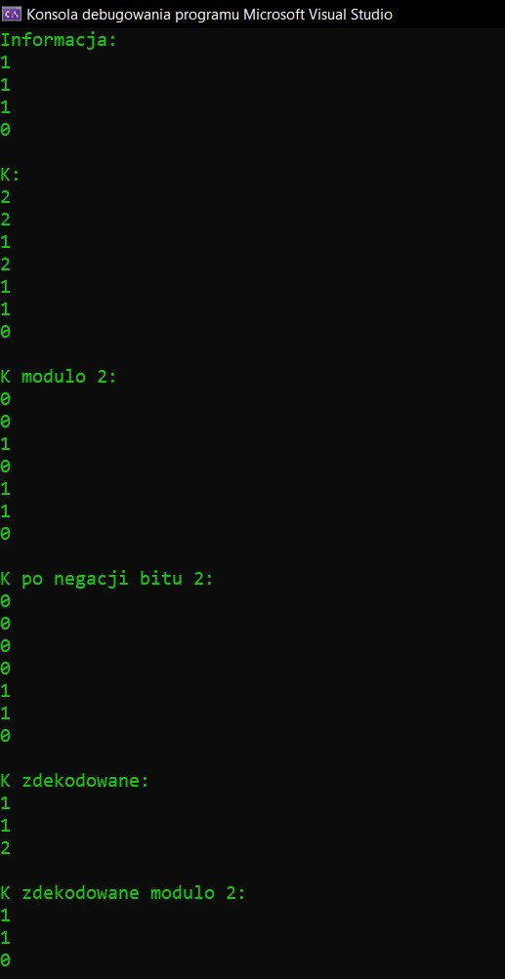

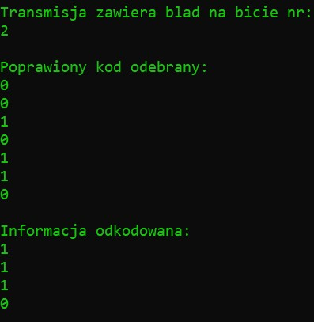

**Wersja SECDEC:**

